# System Architecture

t

## Interfaces

| Reference | Description |
| --- | --- |
| 1 | Power is introduced into the hopper directly from the chemical bottle with a plastic cap used to seal the top of the hopper |
| 2 | Powder hopper aligns with one of 3 chutes to dispense powder into the appropriate selector hole of the vial block |
| 3 | Vials are threaded into the vial block securely and have holes that allow for the introduction of powder, mixers and extraction tubes |
| 4 | Solvent is added manually using a syringe with a silicone tube at one end. The silicone tube is inserted where the extraction tube would be and the solvent is then dispensed from the syringe |
| 5 | A removable male attachment that slots into a female attachment designed to transmit torque between an electric geared stirring motor and the mixers |
| 6 | Pass through slot for mixers that allows for free rotation and coupling to female torque adapter without mixer falling into the vial |
| 7 | Vials secured to print bed using a printed plate attachment with indexes |
| 8 | Stirring motor attached to the printer gantry and screwed into extruder bracket |
| 9 | Serial connection between control PC and printer through which GCODE movement commands are sent – reaction system printer is designated “0” in software |
| R | Stirring motor controlled by Arduino motor shield |
| S | Powder hopper rotated by a 5V stepper controlled by Arduino motor shield. Vibration motor connected to hopper is controlled by Arduino connected MOSFET and driven by 12VDC |
| A | Extraction tubes immersed in solvent and connected to syringes by a series of check valves such that on the upstroke the solvent is extracted from the vials but on a downstroke backflow is prevented |
| B | Check valve such that on upstroke air cannot enter the syringe but on downstroke the extracted solvent is forced through the syringe |
| C | Servo operated lock and key mechanism that turns a key 90 degrees to engage a syringe so that it can be pushed and pulled by the linear actuator. Upon turning again it will disengage the linear actuator from the syringe so that the actuator head can be moved up while the syringe piston stays down |
| D | Dual H-bridge control for linear actuator and peristaltic pump – both devices operate on 12VDC |
| E | Linear rail stepper motor controlled by dedicated stepper controller that receives 12vdc as well as pulse and direction signals from the control PC (5vdc GPIO lines) |
| F | Mounting block that interfaces linear rail slide to syringe holder |
| G | Syringes are held in place on the holder by a recessed feature that interfaces with the wings of the syringe – further secured with tape |
| H | Gap between end of the syringe filter and the filtrate vial – controlled by moving the printer bed motion, vial is selected via vial carousel |
| I | Vial carousel stepper motor controlled by dedicated stepper controller that receives 12vdc as well as pulse and direction signals from the control PC (5vdc GPIO lines) |
| J | Serial connection between control PC and printer through which GCODE movement commands are sent – dilution system printer is designated “1” in software |
| K | Peristaltic pump transmits acid from a reservoir container to the delivery tube. Pump is mounted on a raised bracket to avoid spills shorting the coils |
| L | Bracket to connect micropipette and acid delivery tube to the gantry head and extruder bracket |
| M | Dilution vial, filtrate vial and carousel are all secured to the printer bed by a custom indexed plate mounted atop the printer plate |
| N | Indexed holes for the filtrate vials to both position them precisely with respect to syringe filters and to retain them in place as the plate underneath moves |
| P | Acid delivery tube is inserted into dilution vial to minimise acid splash with programmed positions for each vial |
| T | Micropipette tip is retrieved from carousel tip posts and then immersed into the filtrate vial at a programmed position and to a programmed depth before aspiration is done using servo motors mounted to the pipette buttons. Pipette tips are then disposed of automatically in the same manner to a designated waste area with programmed position |

# 3D Printers

The 3D printers used as the XYZ platforms of both dilution and reaction systems are both Monoprice Select Mini V2 3D printers (see figure below). The user manual for this product can be found at <https://downloads.monoprice.com/files/manuals/21711_Manual_170328.pdf>

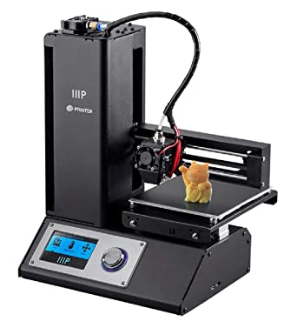

This printer uses an 84W 12VDC external power brick as a power source for both the extruder and heated bed. The outer casing is made of steel and the motor houses four stepper motors: 2x NEMA17 steppers for the printing bed (Y axis) and extruder, a NEMA17 flat form motor for the gantry (X axis) and a low-speed stepper for the tower (Z axis). All motors run on the same 12VDC system as the extruder and heated bed. A custom control board with marlin firmware is installed where the micro-usb and sd card slots are situated in the figure above. All printer systems are connected to this board with the exception of the LCD and selector knob which have a breakout board located behind the LCD panel which uses 5VDC.

These printers were chosen for their ease of disassembly and modification as well as having a mobile build plate which allows it to interface easily with other systems. Firstly, a plastic spacer was used to change the “zero” position of the printer’s Z axis. The fan, fan shroud and extruder are then removed to allow for direct mounting of other components onto the gantry. The extruder and fan are not disconnected electrically, but instead secured to the side spool holder. In the figure below the white object is an example of the spacer used. The position of the limit switch is marked by a red circle. The position and mounting of the extruder and fan are marked by a green circle.

# Reaction System

The reaction system comprises a feeder hopper, powder chutes a selector and vial block and the reaction vials carried underneath the mixers and coupling elements (interface 5) are not shown. The powder hopper has 2 opposing holes which line up with one of three concentric chutes (interface 2) at any given time. Chutes are selected by rotating the hopper with a stepper motor, vibrating the hopper to force powder to fall out and then taking the hopper out of alignment with the chute by performing a small additional turn. The chute dispenses powder into the solid feed channels (interface 6) on the selector and vial block. The first three vials are selected by hopper movement, while the next three are selected when the print bed moves forward in the Y axis to bring them under the chutes. Once powder has been dispensed into the liquid the stirring head will then interface with the selected position and begin agitation for a set period of time controlled in software. When stirring is complete the fluid is extracted by silicone tubing inserted into the extraction holes (interface a).

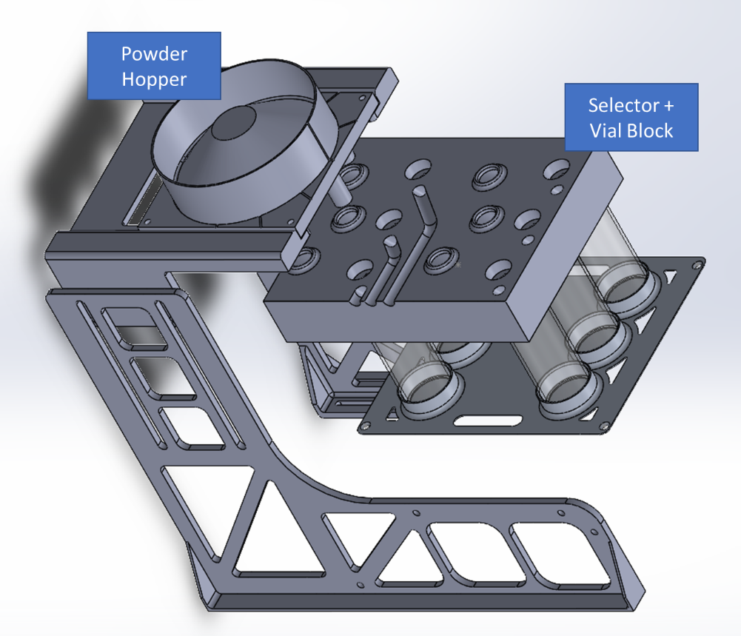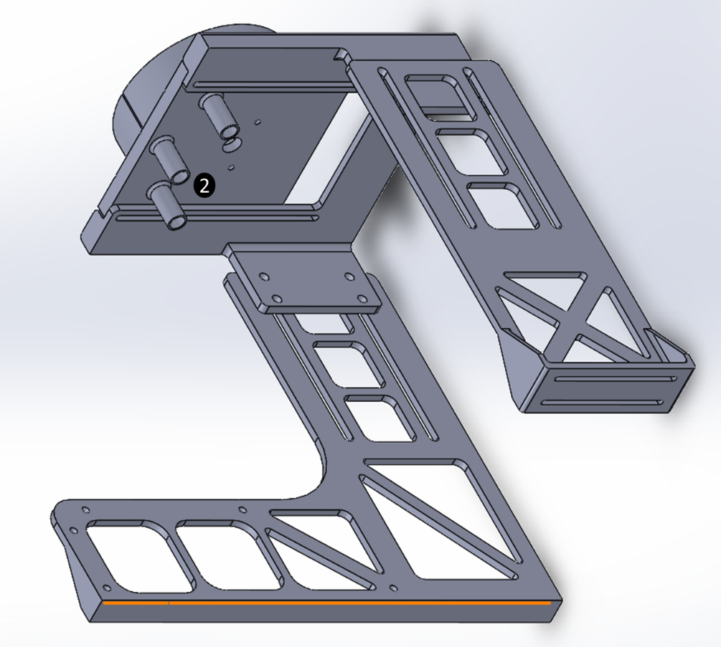

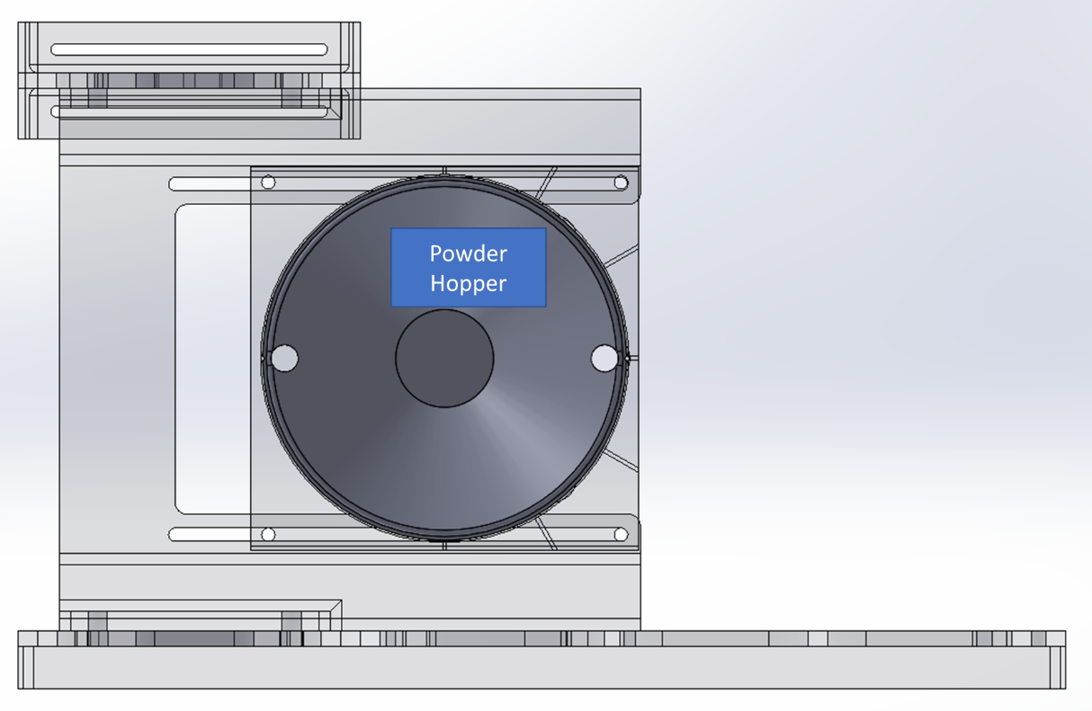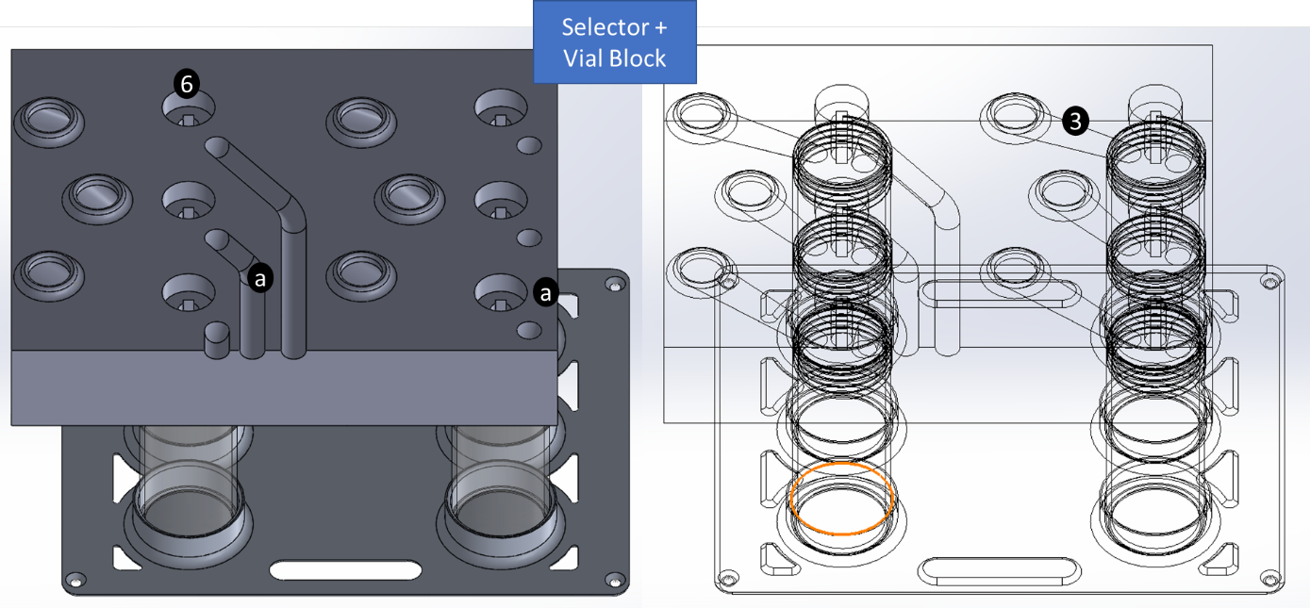

# Filtering & Dilution System

The filtering system makes use of a 12vdc 750N automotive linear actuator to apply filtering pressure to the syringes and filters. A 3d printed (PLA) 4-bar linkage is used as a compact force transmission device which also has the additional safety feature of failing first by fracture in the event of an over-pressure event so that the risk of syringe and/or filter rupture is minimised. During filtering the linear actuator is operated in a pulsing mode of 100ms forward strokes every 3 seconds of wait time. This gives time for the fluid in the syringes to relax and prevents the over pressurization of the syringe filter. The syringe locking mechanism is shown in the figure below under its interface label (interface c). The syringe holder (interface f) allows for 5 syringes to be mounted to the linear rail slide and these are moved forward sequentially so that when one syringe completes filtering the next one is moved under the locking mechanism to repeat the cycle. The filtering system is all contained on a single frame which is designed to minimise net forces across the assembly to confine and minimise mechanical failure.

The dilution system comprises of a 3d printer where the bed is modified to take a carousel and other indexing features designed to carry sample vials. The gantry carries the micropipette (interface l) and the servos which are used to actuate the micropipette automatically (interface t). In the diagram below the printer bed is shown in a forward “deployed” position where the vial loaded onto the frontmost index of the carousel will receive filtrate from the active syringe filter.

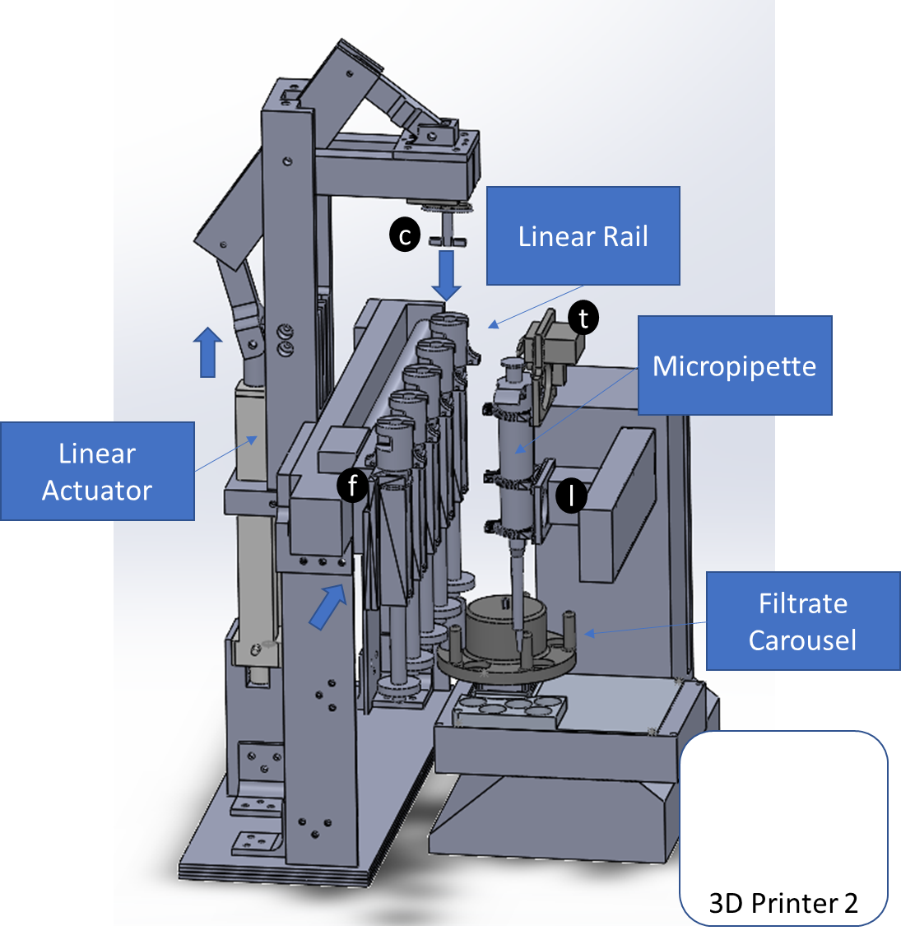

# Control PC

The control PC used in this machine is a Rasberry Pi model 3B with Rasbian OS installed to a 32GB bootable SD. The control PC is powered by a 5VDC 3A mains adapter which is shared with other 5V peripheral devices such as servos and USB devices. 3 USB devices are attached for serial control comprising of an Arduino Uno which draws 5VDC from the PC power supply to power a geared DC motor and small stepper motor to power the reaction system stirrer and hopper respectively, and the two 3d printers which only receive data, not power. The GPIO pins of the control PC are used to control a variety of other peripheral devices. The pinout of the attached peripherals is shown in the figure overleaf. The control PC is connected to the Imperial WPA network with credentials supplied by user em2714. Remote access is configured via VNC server to allow for debug and control of the whole machine. Dynamic IP assignment is used to protect the PC from malicious remote control with the current IP only discoverable by a LCD screen attached to the machine or by a password protected internet service.

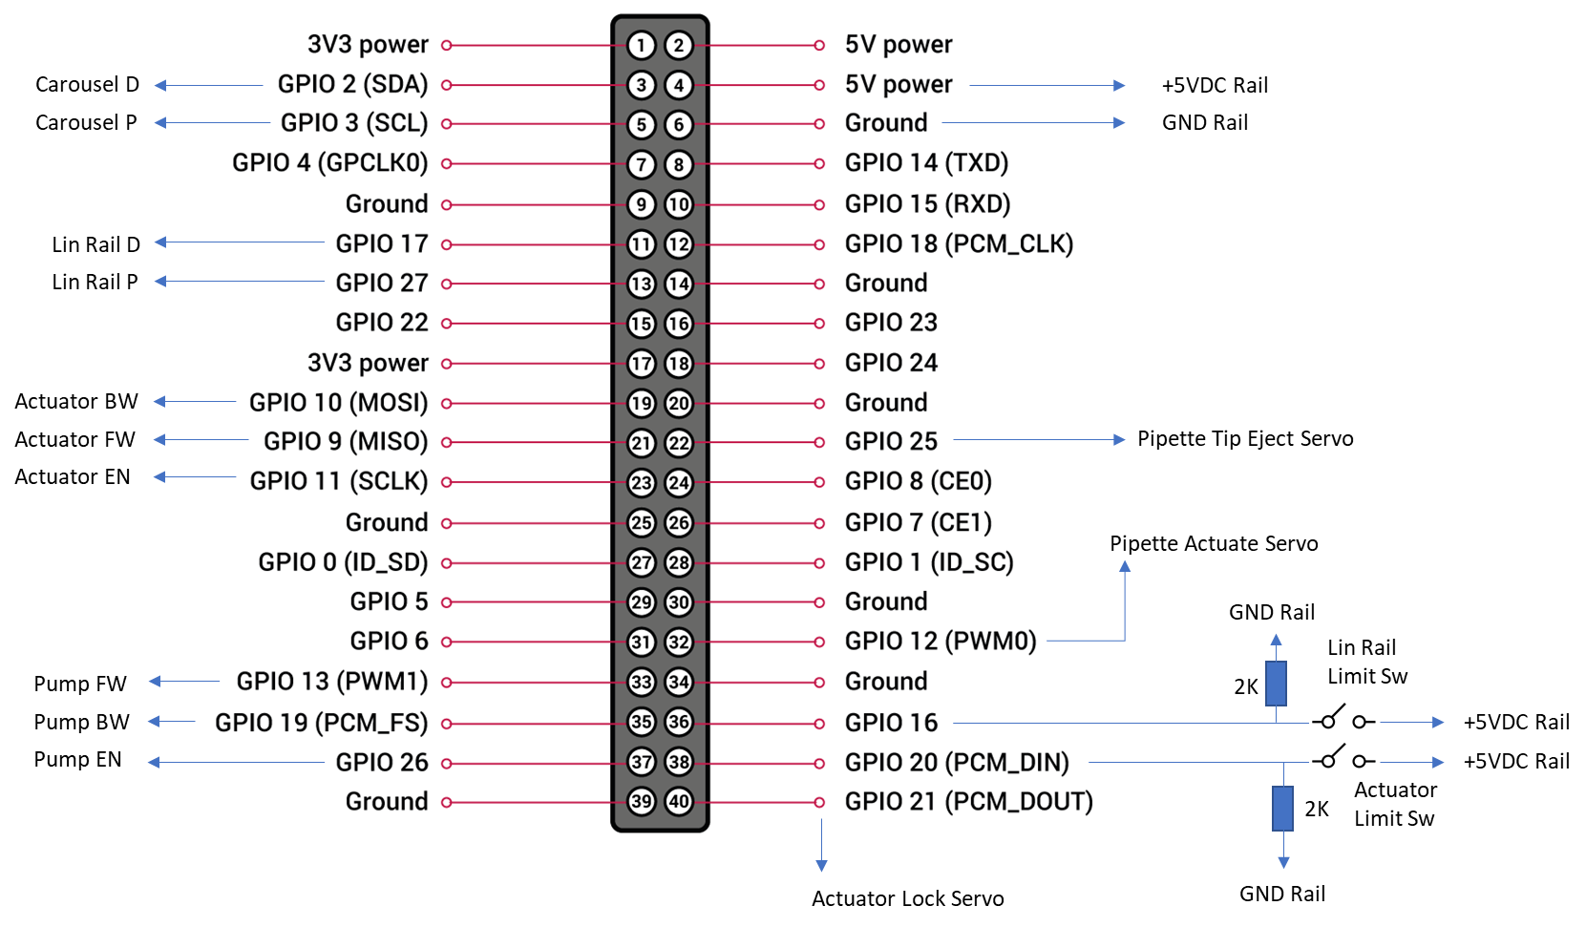

|  |  |
| --- | --- |
| Abbreviation | Description |
| D | Stepper motor direction signal (low = backward, high = forwards) |
| P | Stepper motor pulse signal |
| FW | H-bridge polarity 1 (dc motor forwards) |
| BW | H-bridge polarity 2 (dc motor backwards) |
| EN | H-bridge enable (allows for PWM of attached device) |
| GND | Machine Common Ground |
| Sw | Switch |

# Arduino Microcontroller

The Arduino Uno (ATMEGA32) is used as a ancillary microcontroller for the feeding and reaction system as this system was designed independently of the control PC and the other two systems. Integers between 0 and 14 are sent over the serial connection to the control PC as ASCII and are then decoded by the Arduino and fed into switch case logic to perform the following actions:

|  |  |
| --- | --- |
| Integer received | Action |
| 0 | Print ready status to lcd screen |
| 1 | Rotate hopper to first position |
| 2 | Rotate hopper to second position |
| 3 | Rotate hopper to third position |
| 4 | Reset hopper position |
| 5 | Close hopper |
| 6-11 | Read thermocouples 0-6 (currently not implemented) |
| 12 | Run stirring motor |
| 13 | Run hopper vibration motor |
| 14 | Run vial block vibration motor |

Additionally on power-on the Arduino listens for a character array sent from the control PC. This will be the control PC’s dynamic IP address which will be displayed upon startup.

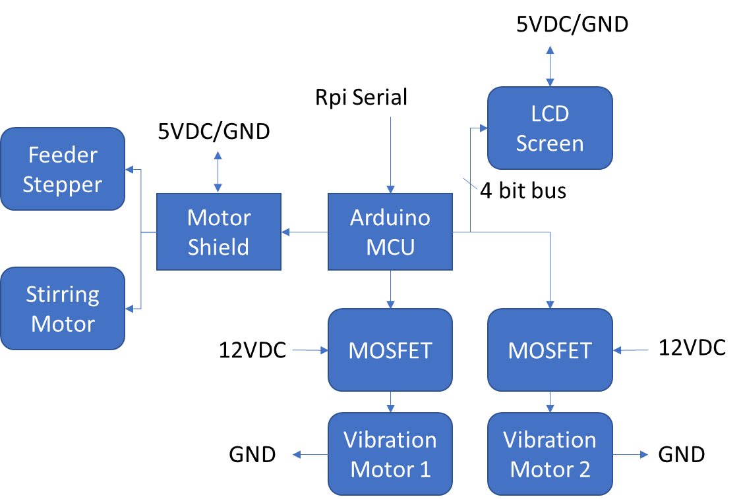

# Physical Assembly & Testing

This machine has been assembled and tested using mainly 3d printed parts and frames in the department of materials (Bessemer B335) according to a provisional risk assessment (see attached RA document) that specifies construction and limited testing work. Liquids and solids have been replaced with non-hazardous substances with similar properties. The substances used for testing are a 3:1 mixture of honey:water and baking soda (sodium bicarbonate). The overall risk of assembly and testing using these materials was assessed to be low. All mains voltage elements of the electrical power supplies passed PAT on 10/11/2021. The overall machine size is 75x65x60cm in LxWxH. Estimated dry mass of the machine is around 10kg based on components.

## Predicted Failure Modes & Mitigations

Devices attached to the H-bridge are actuated by setting a high signal from the control computer GPIO pin and sleeping the script for the desired movement/actuation time before setting the H-brige low again. If the control PC were to encounter an exception in the main script at this point, the GPIO lines would be stuck high causing the peripheral devices to continue running indefinitely until the machine is powered off. The two devices attached to the H-bridge that could fail this way are the peristaltic pump and the linear actuator.

The linear actuator could fail either on retraction or on extension. On retraction, the back bracket and cantilever may be put under sufficient strain to break the plastic, but no other harmful effects are expected due to built-in limit switches on the actuator. These limit switches are however beyond the acceptable range of motion of the force transmission device. On extension, if coupled to a syringe the actuator may exert sufficient pressure to burst the syringe filter and/or syringe. However, as previously mentioned, failure in the 4-bar linkage mechanism is more commonly observed to happen before this, mitigating the risk of leaking hazardous solvent due to syringe/filter rupture.

The peristaltic pump runs forwards for 20s in a priming phase and for 4.5s in the dilution phase. It also retracts liquid for 0.5s immediately after the two aforementioned phases. Failure during the retraction phase is inconsequential due to the deliver of the acid back into the original container, at which point the pump will then be empty and no longer dispensing acid. However this failure mode is unlikely due to the short retraction times. If the pump were to fail during priming, the risk of acid spillage can be mitigated by ensuring that the priming container is the same size as the initial acid container, so that overflow cannot happen. The risk of acid spillage during dilution however cannot be mitigated due to the small size of the vials needed to fit onto the 3d printer bed.

The actuator-syringe locking mechanism is another potential source of failure modes. Firstly, if syringes are not properly aligned with the actuator head, the actuator will apply excessive pressure to the top of the syringe piston. In this state the syringe would have no liquid inside therefore there is no risk of rupture, however there is a risk of breakage of the force transmission device that would leave the actuator head in a lowered position that would interfere with the movement of the linear rail, potentially causing the linear rail stepper to skip and become damaged. Secondly, the actuator lock mechanism could fail to disengage fully with the syringe which would lead to the head being stuck on the top of the piston as the linear rail moves. This would lead to the piston being torn out of the syringe and would lead to liquid contained therein splashing on other machine components. It would also put strain on the linear rail motor causing the stepper to skip and potentially damaging it.

The vibration motors consist of plastic offcuts with an M3 screw threaded into the extremity glued onto the shaft of a 6VDC motor. The motors are overvolted to 12V since more power for powder movement is needed, but these have a low duty cycle and therefore this is deemed safe. However it is possible that the attached plastic may detach without warning due to the high centripetal forces involved. As a result these motors are not be run without eye protection.

Finally if any objects obstruct the movement of the 3d printers during operation this can cause the axis stepper motors to lose calibration, skip and outrun, which can lead to motor damage. Sustained outrun of 3d printer motors which are enclosed in the printer frame will lead to a printer shutdown due to thermal runaway protection. However, the machine has no way of detecting and stopping should there be an obstruction in the printer operation area. Obstruction of the reaction system can come from the silicone tubing that is used for liquid extraction catching on the gantry as the print bed moves past it. The tubing has been positioned to mitigate this. The tubing is made of silicone and is chemically compatible with the solvents used, as it has been used with other apparats in the laboratory with the same solvents.

Some minor snagging is still occasionally observed during operation, but this is not sufficient to cause the printer’s stepper motors to skip and therefore is not deemed a safety issue, however it should be kept under observation. These tubes have not been observed to pull out on snagging due to the large contact area between the tube viaducts and the tubes, however a more secure retaining mechanism and splash guards are to be designed. Exposed conductors and boards will also need to be enclosed to prevent splashes potentially shorting electrical connections.

Obstruction in the dilution system can occur from misalignments from mechanical impacts with other parts of the system if another failure mode were to manifest.

Due to this machine being a first prototype several unmitigated failure modes exist. In response to these it is essential to place the machine in a confined location with a safety screen to protect the user from hazardous material splashes. A lead designated fume hood in LG10A has been identified as a suitable location. It is essential that this machine be always supervised by a trained operator with the fume hood sash all the way down while it is running, so that the main power switch can be turned off in the event in one of the above, or a non-predicted failure mode occurring.

## Whole Assembly Photos

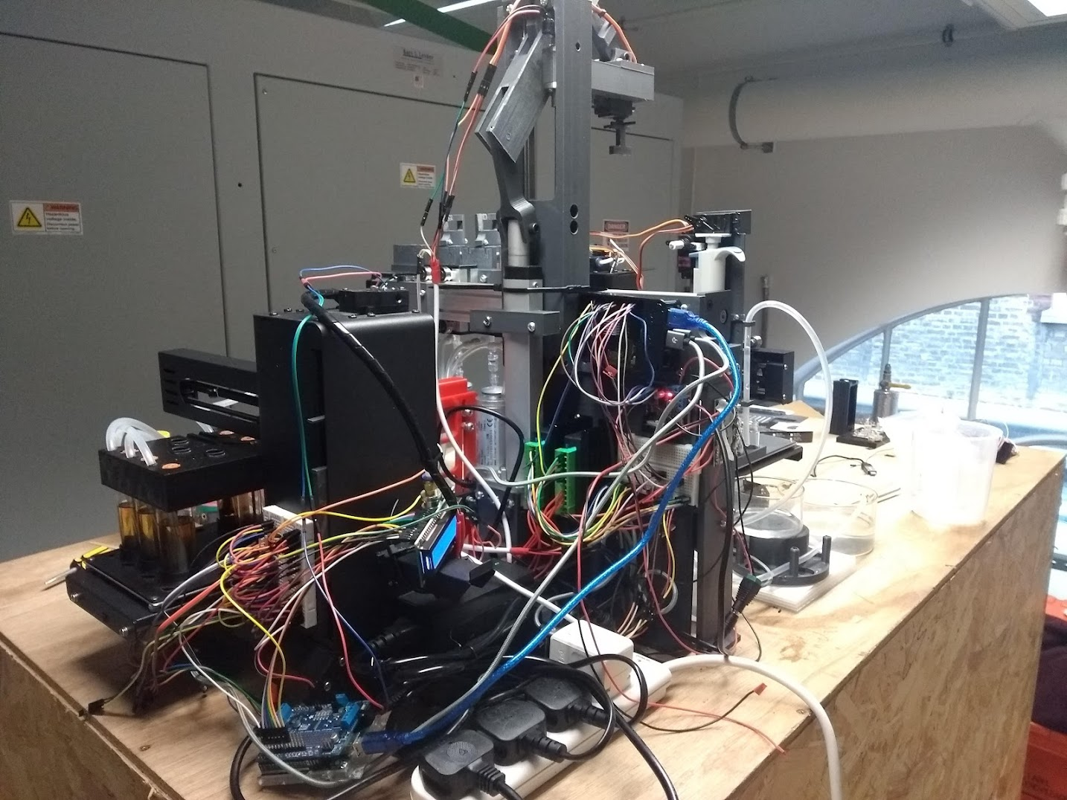

## Syringe Assembly

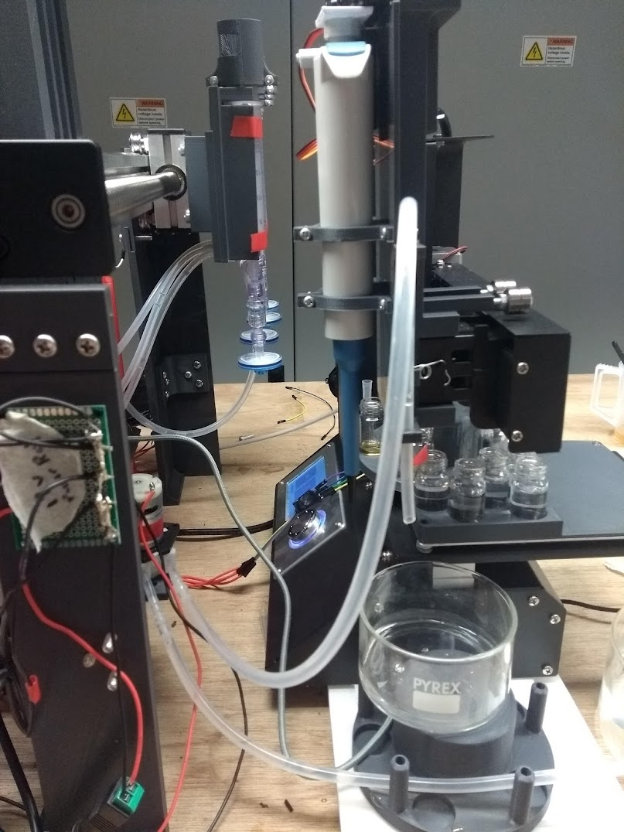

## Reaction System Assembly

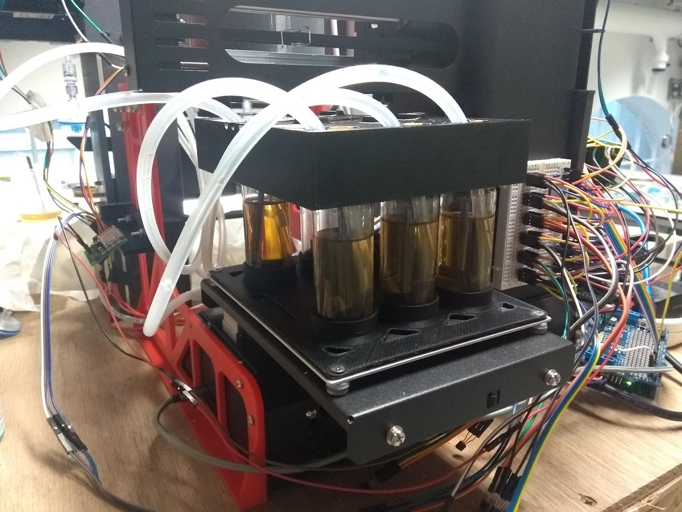

# Machine Control Code

A number of libraries are used and called as necessary for the operation of the machine. These libraries have been attached within this folder. A series of test scripts are also attached for testing the cross functionality of the machine.